TWG7 – Societal benefits and applications
  - Draft contribution to the NuPECC LRP24
Introduction on sustainability: Introduce the sustainable goals as worded by the United Nations and how this section aims at highlighting what nuclear science and applications can contribute towards these goals. (Nathal)

Contents
1. Energy 3
a. Fission reactors 3
b. ADS systems 4
c. Fusion reactors 4
d. Energy sources for space applications 5
e. Waste 5
f. Security 6
g. Perspectives and needs 6
2. Health 7
a. Imaging 7
b. External beam radiation therapy 7
c. Targeted Radiotherapy 8
i. Theranostics 8
ii. Production 9
d. Cross-over 10
i. Radiosensitizers 10
ii. Exploiting nuclear reactions for therapy 10
e. Perspectives and needs 10
3. Space 11
a. Health of astronauts (Charlot) 11
b. Radiation hardness testing (Vincenzo) 11
c. Astrochemistry (Eugenia) 12
d. Nuclear physics in space 12
e. Perspectives and needs 12
4. Climate & environment 13
5. Cross-disciplinary applications 14
6. Nuclear data 15
Types of nuclear data and relevance 15
What do we understand by nuclear data? 15
a. Nuclear data needs & priorities 16
i. Fission Technology 16
ii. Fusion Technology 16
iii. Health applications 17
iv. Material analysis 17
v. Metrology 18
vi. Space applications and Environment 18
vii. Other applications 18
b. Facilities and future experiments 18
i. The role of current and future facilities 18
ii. Target Laboratories 18
iii. Detector developments 19
c. Data Evaluation 19
i. General purpose and specific nuclear data libraries 19
ii. Standards and metrology 19
d. Perspectives and needs 20
7. Nuclear science for a sustainable society 22
a. Towards the planet 22
b. Towards society 22
c. Towards the world, beyond Europe 22
Extra frames 23
Dosimetry 23
Nuclear clock 24
Radioactive molecules 25

Energy
Concepts around the use of nuclear energy, with new systems in both fission and fusion. Emphasize also innovative systems (e.g. SMR, small fusion reactors...).
The new ideas for the future require a lot of nuclear physics input and this what we need to emphasize in this NuPECC LRP. The relevance of nuclear data and perhaps highlight in the perspectives and need what type of experiments and ions are urgently needed. We need to indicate the “families” where we need to get new data and the need for facilities where we can generate these data/experiments.
The idea of meeting 14.07.2023: A global pictures with 2 routes (fusion and fission), going to innovative systems in both fields, without having a strict division in subsections. If subsections would still be used, should we perhaps order them according to delivery in Europe?
Energy generation is a very important field where nuclear physics can have an impact. Indeed, the decarbonization goals and the security of supply represent critical challenges in particular for Europe, and nuclear energy will continue to provide a significant contribution to energy production for decades to come. On the other hand, innovation is becoming more and more important in the nuclear energy field, as indicated by the need to develop novel concepts like the Small Modular Reactors (SMR) together with advanced nuclear systems as outlined in the Generation IV program. At the same time, the fusion community continues to develop the main projects outlined in the global fusion roadmap, ITER and DEMO, while several private or public/private initiatives aim to pursue diversified avenues in the attempt to speed up the achievement of commercial fusion. Specific research for the development of the next generation of fission reactors and for the design of the first fusion reactors is directly linked to several basic research issues: precise cross section and decay measurements, understanding of nuclear reactions, evaluation of data and development of reliable databases, irradiation tests of materials.
Several facilities can contribute to the goal of improving the nuclear database by offering accelerator-detector assemblies where several types of beams, mostly ions and neutrons, can be used for this purpose. The development of neutron beams deserves particular attention, as several laboratories are contributing to expand the offer in terms of intensities and energy, ranging from low intensity beams to perform measurements of fission, capture and other nuclear reactions, to high intensity beams needed to test materials to be used in the harsh environment of next generation nuclear reactors, both fission and fusion.

Fission reactors
Who leads
Who contributes
Long term operations?
- Longer lifetimes? Decreases need of fossil fuels
- Today, we can only implement the large systems
New ideas around SMR pop-up everywhere. What is their extra value in the game? Besides from the financial point of view, where they could really be a game changer. However, we do not change the sustainibility.
Advanced modular reactors (AMRs)

ADS systems
Who leads
Who contributes
Transmutation -> the “solution” to the waste problem by burning it? Are the fast reactors really the solution or are we still producing too much minor actinides?
We would need dedicated burners, where ADS is probably the best performing system (molten salt).
In the case of ADS, it is necessary to continuously extract fission products online.

Fusion reactors
Fusion reactors are considered as one of few possible alternatives for the production of CO2-free energy in the long term. During the last few years, the overall interest has increased very significantly both in the public as well as in the private sector. This was triggered by a number of very relevant milestones, which were recently obtained by fusion scientists, including the world record of fusion energy production at JET on March 22 (59 MJ) for the case of magnetic fusion [^{[1]}] and the first demonstration of a significant net energy gain due to fusion reactions (around 50% gain for a production of around 3 MJ of energy) in the case of inertial fusion [^{[2]}] .
In the private sector, a significant number of startup companies, have received very significant investments (in the range of several billions of dollars up to now) in the EU, US and Japan, to develop a very wide portfolio of different approaches to fusion energy production besides the classical D-T reactions (and even proposals on aneutronic fusion reactions received funding) [^{[3]}] as well as to focus on the fusion supply chain. Due to the very different approach in the private sector, much more tolerant to risk, this will most probably accelerate the generation of new results coming out from these companies.
These important developments have induced a significant acceleration of the different national and international fusion programmes. It the next few years it is expected the start of operation of a number of relevant plasma physics experimental machines (JT-60 in Japan, DDT in EU, CFETR in China, SPARC and NSTX-U in US, STEP in UK,…) in parallel to the significant progress expected in the assembly of ITER.
Many of these projects rely on proper knowledge and characterization of different nuclear processes, which are not fully characterized in some cases, as well as in the use of modelling codes (for example for the transport of particles and radiation) that should be properly validated. It is therefore important to collect accurate data as well as to closely follow recent developments and results in order to allow a continuous optimization and validation of current state of knowledge in the field.
In addition, the construction of a fusion reactor also requires an improved understanding of radiation effects on materials’ properties. The latter is one of the key challenges due to the extremely high flux of high-energy neutrons on reactor material and components. In this respect, it is also very relevant to note the start of the construction of the IFMIF-DONES Facility. It will be an intense neutron source based on d-Li interaction able to produce up to 1018 n/s (fusion-like ones). This unique facility will become operational in the next decade and holds the potential to allow the construction of a world-class n-TOF facility that can significantly contribute to the production of improved cross-section data required by the development of fusion reactors technology but also by many other scientific and technology areas with societal impact. Improvements in the nuclear physics information presently available, both in terms of data and theories, should be pursued with high priority in the next few years.
^{[1]} European researchers achieve fusion energy record - EUROfusion (euro-fusion.org)
^{[2]} DOE National Laboratory Makes History by Achieving Fusion Ignition | Department of Energy
^{[3]} “The global fusión industry in 2023” Fusion Industry Association (Fusion Industry Reports - Fusion Industry Association)

Energy sources for space applications
Who leads
Who contributes

Waste
The decay time and amount of radioactive products from nuclear reactors operation determines whether disposal of radioactive waste requires either short- or long- or very long-term storage. While for short- or long-term storage, surface or near surface disposal can be adopted, for the very long-term (in particular for the case of direct disposal of spent fuel) a possible solution envisaged is storage deep underground in the so-called geological repositories. Surface or near-surface disposal facilities are safely in operation since many years in several countries around the world [1]. International recommendations (e.g. [2]) have guided national policies, strategies and programmes for the management of spent fuel and radioactive waste. Continuing research on the optimal choices of sites and the prediction of the time evolution of the waste packages underground is performed at international level. In particular, Euratom has promoted the advancement of research on several aspects of decommissioning technologies (SHARE Euratom project [3]), as well as on aspects and issues arising in interim storage, pre-disposal (PREDIS Euratom project [4]) and final disposal, where in the latter point the scientific aspects of deep geological disposal are of special interest (EURAD Euratom project [5]). In order to reduce the amount of waste to be disposed of in geological repositories, it has been proposed to burn at least part of the nuclear waste with Accelerator Driven Systems (ADS), based on a subcritical reactor core (see above Section on ADS).
The theme of innovation in decommissioning of nuclear installations and in surveillance of nuclear waste repositories for predisposal has recently been pursued for instance in the Euratom projects MICADO [6], PREDIS [4] and CLEANDEM [7]. Here, several European laboratories contributed to develop novel solutions to integrate state-of-the-art radiation detectors, often developed for nuclear and particle physics experiments, into digital technologies and robotics, with the aim to enhance Safety by reducing human interventions and consequent radiation exposure on one side, and to maximize the availability and interoperability of data for the bookkeeping of the waste inventories on the other.
Some of the above applications with state-of-the-art radiation detectors may clearly have applications to the Security and Safeguards sectors.
- Storage and Disposal of Radioactive Waste. © 2016-2021 World Nuclear Association, registered in England and Wales, number 01215741.
- Disposal of Radioactive Waste - Specific Safety Requirements No. SSR-5, www.iaea.org/publications/8420/disposal-of-radioactive-waste. © IAEA, 2011, 2011.
- StakeHolder-based Analysis of REsearch for Decommissioning, https://share-h2020.eu/. Research funded by Euratom, Grant agreement ID: 847626, 2019-2022.
- PRE-DISposal management of radioactive waste, https://predis-h2020.eu/. Research funded by Euratom, Grant agreement ID: 945098, 2020-2024.
- European Joint Programme on Radioactive Waste Management, https://www.ejp-eurad.eu/. Research funded by Euratom, Grant agreement ID: 847593, 2019-2024.
- Measurement and Instrumentation for Cleaning And Decommissioning Operations, https://www.micado-project.eu/. Research funded by Euratom, Grant agreement ID: 847641, 2019-2023.
- Cyber physicaL Equipment for unmAnned Nuclear DEcommissioning Measurements, https://cleandem.wordpress.com/. Research funded by Euratom, Grant agreement ID: 945335, 2021-2024.

Security
Safety, Security and Safeguards. Here the flavor could be given by experimental nuclear physics. New detectors/instrumentation. Adaptations for surveillance of nuclear waste.
Is there overlap with environmental monitoring here? In the case of “Energy” this could really focus on specific applications for nuclear installations, transport, port control...
Enhancing Security also means to develop new technologies for the investigation of nuclear materials, be they stored in repositories or transported, and for the investigation of containers as a mean to fight illicit traffic of nuclear materials and terrorism. For instance, high-brilliance gamma sources as the ones developed at ELI-NP may be used to implement active interrogations based on nuclear resonance fluorescence (NRF). Also some of the advanced detectors illustrated in Section 5 may be utilized for security applications, e.g. the detectors specifically developed for installation on ground robots may be modified to be used on drones for cargo inspections.

Perspectives and needs
We also need improvements in radiation transport calculations, which is not only related to the nuclear libraries (simulations/coding -> TWG Open Science?)

Health
Introductory words by Charlot Vandevoorde & Thomas Cocolios

Imaging
Section by Katia Parodi
Contribution by Seán Collins on quantitative imaging
Contribution by Enrique Nacher on imaging with protons and neutrons
Beyond the use of medical imaging for diagnosis, all treatment plans involving ionizing radiation in the form of external beams or direct application of radiopharmaceuticals are based on images taken with X rays in most cases. In the case of hadron therapy, developed further in the next section, this poses a problem. Hadrons, such as protons or carbon ions, and X rays interact very differently with matter. Therefore, a direct X-ray image, such as the one taken with a standard CT scanner, provides a map of X-ray attenuation coefficients encoded in the so-called Hounsfield Units (HU), whereas the image one needs to plan for treatment with hadron beams is the one providing relative stopping powers (RSP). The conversion from HU to RSP is not exempt from problems and implies uncertainties around 3% in the calculation of the hadron ranges in soft tissue. One alternative, perhaps the most accurate but at the same time the most complex, is the use of hadron beams themselves, rather than X rays, to take the primary images for the treatment plan.

External beam radiation therapy
Section by Charlot Vandevoorde, Katia Parodi, Anne-Marie Frelin, Vincenzo Patera, and Ana Vaniqui
External beam radiation therapy has known important improvement since its beginning, mainly thanks to beam delivery and imaging advancement. This progress permitted a significant increase of life expectancy for many cancer indications. Yet, after treatment efficiency, quality of life after treatment has become a major objective. Moreover, some cancers still present poor prognosis and need new therapeutic solutions. To answer this need, technological developments are still ongoing but differentiated biological response between tumoral and healthy tissues has become a key aspect to design new treatment modalities. Thanks to research in these two directions, two main domains have the potential to provide future treatments of radiotherapy: the use of ion beams and the development of innovative delivery techniques.
    - Particle therapy
The advantages of particle beam therapy, namely Bragg peak dose delivery profile and high Linear Energy Transfer (LET), have been demonstrated for a long time. Thanks to these advantages and technological developments (compact gantries, compact accelerators, up-right modalities), the number of proton therapy centers quickly increases, providing access to more patients.
Still, improvements in proton therapy are achievable, in the domain of small volume targets or hypofractionation for instance. LET variation of protons (and consequently RBE variations) between the plateau and the Bragg peak is also of interest. To reach these improvements, instrumental and method developments are needed in the fields of dosimetry, quality control or LET measurements.
Besides the ballistic advantage of protons, carbon ions (and heavy ions in general) present assets in terms of biological effect, with a significantly higher relative biological effectiveness (RBE) at the position of the Bragg peak (corresponding to the tumor position) than in the plateau, and a better efficiency on radioresistant hypoxic tumors. Nevertheless, these assets are counterbalanced by the fragmentation of carbon ions in the tissues, generating a mixed particles fluence. Hence fragmentation cross-sections, LET distributions and RBE for all produced particles must be accurately known to describe absorbed and biological dose distributions. This still requires measurements, instrumentation development, and multi-scale biological modeling.
The development of particle therapy (slowly) increases in Europe with new facilities in service (CNAO...) or in construction (ARCHADE...), supported by technological developments (development of the compact C400 cyclotron for instance).
    - New frontiers in EBRT (FLASH, mini-beams...)
While conventional delivery techniques usually rely on homogeneous dose distribution, moderate dose rate and temporal fractionation, some new techniques break with these paradigms and show promising results in terms of healthy tissue recovery while maintaining tumor control.
These rupture techniques include FLASH radiotherapy, which uses ultra-high dose rate (> 40 Gy/s). This technique has already shown very promising results with different kind of particles, with a significant decrease of toxicity in healthy tissues, and arouses great enthusiasm in the international community.
Spatially fractionated radiotherapy (SFRT) also breaks with standards by using minibeams delivered following a grid and resulting in heterogeneous dose distributions. This technique is intended to reduce the toxicity in normal tissues and has given promising results at the preclinical stage with protons.
For both techniques, the understanding of underlying biological mechanisms is still limited and needs extensive study. It must be noted that FLASH effect (an SFRT effect?) can only be observed in in vivo models or in a few alternative models such as zebra fish eggs, which limits the facilities where such experiments can be performed. Biological studies must also be accompanied by challenging technological developments in terms of accelerators, beam control and dosimetry instrumentation.
Boron neutron capture therapy (BNCT) is at the frontier between EBRT and TRT. It is based on a boronated vector targeting tumor cells, followed by an irradiation with epithermal neutrons. This technique has the advantage of minimizing the effect of nonspecific targeting thanks to the activation by external beams. The interest in this modality is renewed by the development of compact accelerator sources, compatible with hospital practice.

Targeted Radiotherapy
Section by Thomas Cocolios, Charlotte Duchemin, Anne-Marie Frelin, Enrique Nacher, Renata Mikołajczka, Zeynep Talip
Targeted radiotherapy, which relies on the targeting of tumor cells by radio-labelled bio-vectors, leads to a localized dose deposition at the tumor position. This modality is thus particularly adapted to the irradiation of diffuse cancers or tumors difficult to treat by EBRT. Nevertheless, it also raises many challenges in various scientific domains: nuclear physics, radiochemistry, radiobiology and medicine. (…)

Theranostics
  - Targeted alpha therapy
  - Beta emitters
  - Auger emitters
  - Nuclear data (E Nacher) & Dosimetry??
The widespread utilization of radionuclides for therapeutic and diagnostic purposes is well-established across various medical techniques and conditions. The effectiveness of these treatments, as well as the minimization of unintended radiation exposure in both diagnosis and therapy, depend on various factors, one of the key ones being the accurate knowledge of the decay characteristics of the radionuclide in use. This includes considerations such as the types of particles and radiation emitted, their energy levels, and the probabilities of emission. These factors play a crucial role in calculating the dosage administered to patients in medical imaging and therapeutic treatments involving radioisotopes.
In a recent publication authored by Nichols [NIC22], a compilation of radionuclides currently employed or having potential applications in the medical field, along with identified shortcomings in their decay data, is presented. Within this list, the author explicitly outlines instances where some crucial nuclear data is missing and recommends a new measurement (e.g., conversion electrons) or a new technique (e.g., Total Absorption Gamma Spectroscopy) to fill in the gaps.

Production
  - Irradiation (targets & facilities)
  - Chemical separation (Zeynep)
  - Physical separation (Thomas & Charlotte)
At present, there are several isotope mass separation facilities planned to be built or being under development around the world. Naturally, the status of the development and progress of these facilities varies due to factors such as funding, technological challenges and international collaborations. Among those which are already in operation, and which are being upgraded, we find SPIRAL2 at GANIL (Grand Accélérateur National d'Ions Lourds) in France. It aims to provide a large variety of isotopes for various research applications. Similarly, at RIKEN in Japan, the Radioactive Isotope Beam Factory (RIBF), is being expanded and provides a wide variety of isotopes for nuclear physics and interdisciplinary research.
Concerning the facilities that are under development or in various stages of construction, we shall cite FAIR (Facility for Antiproton and Ion Research) as GSI in Germany, ISOL@MYRRHA in Belgium, SPES (Selective Production of Exotic Species) in Italy, and TATTOOS (Targeted Alpha Tumour Therapy and Other Oncological Solutions) at PSI in Switzerland. MYRRHA aims to produce isotopes through the Isotope Separation Online (ISOL) technique similarly to ISOLDE at CERN. SPES on the other hand is a new facility for the production of radioactive ion beams for various applications. Both of those facilities also target medical applications, which is also the goal of TATTOOS, that aims to develop new pharmaceuticals for theranostics specially using the Tb triplet (Tb-149,152,155). Another important contributor to theranostics is the CERN-MEDICIS facility, the first mass separator dedicated to the production of medical radionuclides built in Europe. It produces, since 2017, a unique wide range of isotopes for medical applications, thanks to the high energy beam delivered by the CERN PS Booster (1.4 GeV). The combination of therapy and diagnosis is a rapidly growing field that has considerable potential with respect to treatment but also to improve the quality of life for patients. The use of the mass separation technique allows for increasing the purity and specific activity of the final product. This has been recently demonstrated with Sm-153 produced at SCK CEN (BR2 reactor) and mass separated at CERN-MEDICIS, showing the potential of mass-separated Sm-153 to significantly reduce the amount of stable Sm-152 in the final product and allow for use of Sm-153 in targeted therapy and not only for pain palliation.

Cross-over

Exploiting nuclear reactions for therapy
Include input from Gaia Pupillo
Nuclear cross section measurements of fragmentation products in hydrotherapy (e.g., p + C, O, N ; C + C, O, Si) and radionuclides production for innovative radiopharmaceuticals (e.g., charged-particle induced reactions), including the measurement of co-produced contaminants.
Strong interaction with Nuclear Data (IAEA Nuclear Data needs for medical applications), Dosimetry and Nuclear Modelling.
    - Radioactive hadron therapy
Section by Thomas Cocolios and Katia Parodi

Drug development (Giles)

Perspectives and needs
Including a comment on nuclear data by Seán Collins, on Monte Carlo modeling by Enrique Nacher, on the importance of reliable protocols and biological models by Anne-Marie Frelin, and on benchmarking biological effects by Anne-Marie Frelin and Charlot Vandevoorde.
New treatment strategies, especially the ones based on differentiated biological mechanisms, require multiscale assays before clinical trials to identify new strategies or to evaluate new treatments. These assays range from in vitro evaluation (with various models: 2D cell culture, organoids...) to in vivo experiments. The diversity of scales and geometries is thus challenging in terms of dosimetry. Even if progress has been made (particularly in preclinical radiotherapy), radiobiology experiments often lack adapted instrumentation and methods to provide accurate and reliable dose measurement. Developments in this domain are necessary to improve experimental reproducibility, allow intercomparison between experiments, enhance the valorization of radiobiology assays, and benchmark radiobiology numerical models.
It must be noted that beam access for EBRT, and isotopes assess for TRT are essential to improve and develop treatments. Nevertheless, it must be noted that many facilities are single-room clinical centers, which limits access for research. New therapeutic strategies also strongly rely on various and complementary scientific domains (physics, biology chemistry, medicine) and a truly interdisciplinary approach is required.
Comment on MC (E Nacher), to be included in the best place you might think:
Monte Carlo simulations are considered nowadays the Gold Standard in radiotherapy dosimetry in all its modalities, either proton-, photon-, or electron-based beams. However, the description of physical processes in the low-energy domain is far from settled (photons and electrons with energies below 150 keV). These particles are to appear independently of the initial energy beam as part of the scattered radiation and will play a very important role in the final energy deposited in living tissue. On top of that the low energy electrons involved will have to be accounted for explicitly, and as precisely as possible, in any model designed to incorporate directly biological effects.

Space
As a starting point, we will allocate the different abstracts from community contributions to the first three sections and will use this as a starting point for the write-up. In the meantime, all of us will reach out to the space community and interested parties (e.g. Italian Space Agency, European Space Science Committee, materials research community…) who might have missed this NuPECC call for contributions.

Health of astronauts (Charlot)

Radiation hardness testing (Vincenzo)
Radiation hardness testing plays a critical role in the development and selection of detectors for space missions. To evaluate the radiation hardness of space components in general and radiation detectors in particular, several types of tests are conducted. Total Ionizing Dose (TID) testing exposes the detectors to a cumulative dose of ionizing radiation, to simulate the long-term effects of space radiation. The detectors are monitored during and after exposure to assess changes in performance, such as gain, noise levels, and response time. The detectors are evaluated for changes in electrical properties, such as leakage current and charge collection.
There is a necessity to evaluate the sensitivity of components in order to gauge their reliability. Single Event Effects (SEE) testing focuses on the transient effects caused by energetic particles striking the detector. These effects include Single Event Upsets (SEUs) in digital circuits, Single Event Latchups (SELs) in power devices, and Single Event Functional Interrupts (SEFIs).
SEE testing usually involves exposure of detectors to particle beams or heavy-ion irradiation to evaluate their susceptibility to these effects and ensure their resilience. Another important test is Displacement Damage (DD) testing, which assesses the ability of the detector's crystal lattice to withstand displacement of atoms due to ion collisions. This testing typically involves neutron irradiation, as neutrons can induce displacements within the crystal structure.
Focusing on SEE, is of paramount importance to determine whether these events occur once every 10,000 years or on a daily basis. This assessment helps to determine the component's suitability for the mission and whether mitigation strategies can be implemented, such as localized shielding or global shielding around the equipment box. However, as devices become more complex, testing becomes increasingly challenging. Modern ASICs (Application-Specific Integrated Circuits) or FPGAs (Field-Programmable Gate Arrays) contain millions of transistors, making it difficult to identify all the potential disturbances that an SEE might trigger.
Testing process typically begins by simulating the space environment using heavy ions. If the test item proves to be highly sensitive, then the proton testing as well can be used as further benchmark. While we have powerful simulators to assist in evaluating these effects, their usefulness becomes apparent once the initial sensitivity is confirmed.
For specialized high-energy testing, space Agencies collaborate with a network of nuclear labs across Europe. For instance, Switzerland's Paul Scherrer Institute has a Proton Irradiation Facility designed for high-energy proton beam testing of satellite components.
Mitigation techniques are used to reduce the sensitivity of microprocessors from the outset. One approach is "error detection and checking," which involves adding an additional bit to each memory word, placed in various quadrants of the chip for quick disruption identification. Customized software for memory devices performs additional checks to repair any damage, while "triple redundant voting" exploits parallel circuit branches to cross-check each other for errors, taking a vote when uncertain about which branch contains an error.
However, it's important to acknowledge that implementing these techniques may come at a cost in terms of overall functionality and potentially speed. Component designers must carefully consider trade-offs, deciding whether fully radiation-hardened components are necessary or if a certain level of error tolerance is acceptable in exchange for greater processing speed and flexibility.
Looking ahead to future missions, the Galileo satellite navigation system, which must maintain a high level of accuracy throughout each satellite's 12-year lifespan while orbiting through the outermost Van Allen Belt, is a top priority.
In this field an important role is played by the European Cooperation for Space Standards (ECSS), that oversees a comprehensive set of space manufacturing standards, among which there are the Radiation Hardness Assurance standards that set the acceptance limit for the devices tested for radiation hardness in space missions.

Astrochemistry (Eugenia)

Nuclear physics in space
Gather some new ideas in the coming weeks
The radiation field composition and particle anisotropy are crucial factors in estimating the radiation dose received by astronauts. These features are also due to the particle production that occurs in the interaction of the Galactic Cosmic Rays with the materials of spacecraft and of the shieldings. Uncertainties in these factors, as well as particle rate and dose, can affect the accuracy of health risk predictions for specific space missions.
In particular the neutron production is crucial in the radiation spectrum, with a dose contribution that depends on shielding thickness and that can have a broad energy spectrum up to 1 GeV. Furthermore neutrons become particularly significant in planetary bases with shielding against charged particles but not neutrons. It must be remarked that the space neutron spectrum differs from the typical fission spectrum used in Earth-based measurements.
The production cross section of both neutrons and charged ions from interaction of He, C, O, SI and Fe ions on the spacecraft shielding material are crucial to assess the dose contribution to astronauts.
Space-based experiments are ideal for studying the radiation field experienced by astronauts. However, these experiments have limitations such as the lack of advanced equipment, high costs, limited manpower, and uncontrollable irradiation parameters. Ground-based facilities, on the other hand, offer easier access and lower costs. An overview of the European accelerator facilities of interest for space application is reported in Table 1. AS it can be noted, there is a lack of high-energy neutron sources, including Quasi-Monoenergetic Neutrons (QMN), that heavily hinders research on high-energy neutrons in space.

Perspectives and needs
Quasi-Monoenergetic Neutron (QMN) sources

Climate & environment

Cross-disciplinary applications
Very advanced but I did not have access to the file just now…

Nuclear data
Nuclear theory is not capable of predicting the fundamental nuclear properties, nuclear performances and safety and security margins with enough accuracy for technological applications. Therefore, the accurate determination of these properties, hereafter called as nuclear data, must come from dedicated experiments and an evaluation, consisting of the interpretation with theoretical models and a later validation with benchmarks sensitive to the quantities of interest. These benchmark experiments require also benchmark and reference radiation fields generated in dedicated experimental facilities.
Nuclear data and associated tools are a critical element for applications and research, playing an essential role in the simulation of nuclear systems or devices for nuclear energy and non-energy applications, for the calculation of safety and performance parameters of existing and future reactors and other nuclear facilities, for the innovation of the design of those nuclear facilities and the innovation on radioactive devices and use of radioactive materials in non-energy applications, and for the interpretation of measurements in these facilities and systems.
Nuclear data final users are most often nuclear engineers and scientists working for nuclear safety authorities, radioactive waste management institutions, operators of nuclear and radioactive facilities, engineering companies developing innovative nuclear devices and applications, hospital health physics and nuclear medicine units, institutes involved in nuclear technologies research, basic research, environmental nuclear applications and other non-energy nuclear applications.
No matter how sophisticated the tool is, no simulation, calculation or interpretation of measurements can be better than the limit imposed by the nuclear data they use. Several parameters, particularly safety parameters and associated margins of reactors and other nuclear facilities, need to be known with a precision well below 0.1% resulting in nuclear data precisions better than a few percent, sometimes better than 2%, and this is a serious challenge. In other cases, the precision needed can range from 5% to 20% but the isotope or material to be measured is highly radioactive or very scarce raising a different but also important challenge.

Types of nuclear data and relevance
The most common classification of nuclear data distinguishes between microscopic and macroscopic or integral data. The first group addresses microscopic nuclear properties measured individually or as a function of an observable such as energy or the emission angle. These data are usually referred as differential data. On the other hand, integral benchmark experiments provide global measures, integral data, with typically better statistical accuracy than differential data. The measured integral quantities are a function of the microscopic data and serve as a very valuable resource for nuclear data testing and evaluation efforts.
[Danel i½ page;]

What do we understand by nuclear data?
It is a complete cycle, show the nuclear data cycle for pedagogic purposes.
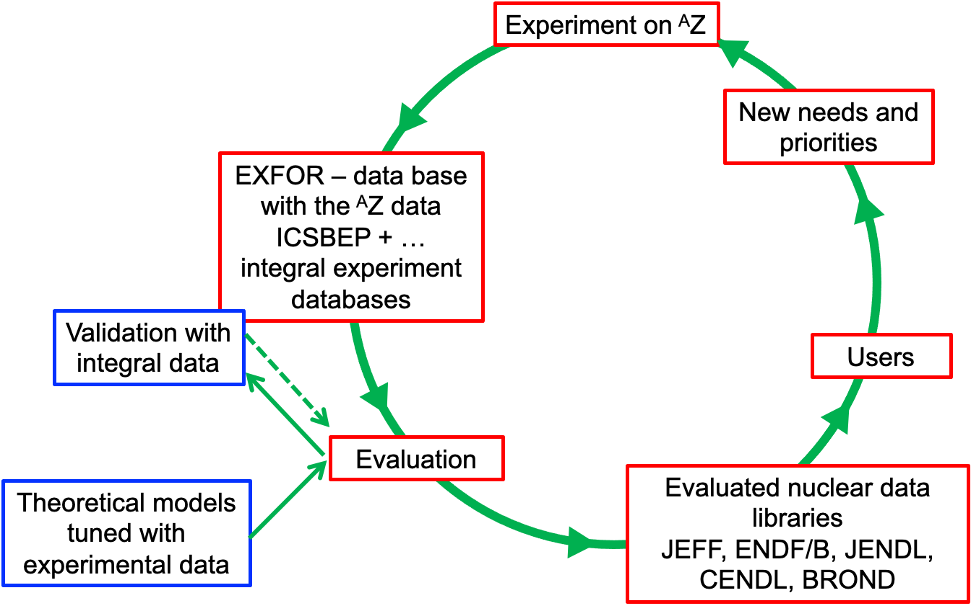

Nuclear data needs & priorities

Fission Technology
[Arjian Plompen, here] (1 page)

Fusion Technology
Nuclear fusion is one of the long-term sustainable energy sources currently subject of intense Research and Development activity. The design, construction and safety operation of fusion reactors require a large set of nuclear data. One of the most important issues regards the effect of radiation damage on structural materials in the inner part of the tokamak, such as the blanket and the divertor, subject to extremely large flux of 14 MeV neutrons (and lower). Neutron interaction with structural material, and in particular inelastic scattering, capture and (n,cp) reactions are responsible for displacement, transmutation and gas formation, that lead to substantial modification of the thermo-mechanical properties of the structural elements of a fusion reactor materials, limiting their lifetime.
While the neutron damage in fusion reactors can be assessed experimentally at neutron irradiation facilities like IFMIF-DONES, the interpretation of the results and model calculations rely on neutron interaction cross section, up to several tens of MeV. Reaction data available in the Fusion Evaluted Nuclear Data Library (FENDL), and activation cross sections from the European Activation File (EAF) needed to address safety, licensing, decommissioning and waste management issues, are often based on scarce or discrepant measurements, or in a limited energy range. For this reason, there exist a pressing need of new neutron data, for a variety of reactions and isotopes, and in a wide energy range. Thanks to their neutron energy spectrum, the Neutrons For Science at SPIRAL2 and neutron Time-of-flight facility n_TOF at CERN are some of the best suited for addressing the lack of neutron data related to fusion. In particular, the high flux and the wide energy range of the neutron beam make NFS and n_TOF ideal places for measurements of (n,xn) and (n,cp) reactions.
With the purpose to collect much-needed data of neutron-induced reactions relevant to fusion energy applications, the n_TOF Collaboration has developed state-of-the-art detection systems. Energy-differential cross section of (n,cp) reactions will be measured up to at least 60 MeV neutron
energy, in the two experimental areas placed at 185 and 20 m from the spallation target, while activation cross sections will be measured in the so-called NEAR station, placed at 1.5 m from the spallation target. Measurements will be performed, for example, on Be, Fe, Mo and W isotopes, among the most relevant for assessment of damage of structural material under neutron irradiation in ITER and DEMO.
[Nicola Colonna] (½ page)

Health applications
Isotope production, dosimetry – treatment planning
Logistics? (e.g. transport, characterization) Or does some of that better fit under Metrology?
[Seán Collins, Claude] (½ page)

Material analysis
Ion Beam Analysis (IBA) techniques, along with the complementary ones based on neutron-induced reactions, such as NAA (Neutron Activation Analysis) and Neutron Imaging, permit the in situ, least–destructive analysis and imaging of – mainly – surface layers of materials, yielding highly accurate quantitative results. IBA constitutes a strong, highly popular, interdisciplinary field, which is continuously enriched and evolving, applying Nuclear Physics knowledge and expertise in Material Science. Thus, IBA extends the importance of Nuclear Physics to a large variety of different fields, ranging from semiconductor studies and nanotechnology, to environmental, geological and cultural heritage applications. Therefore, it is not surprising that nowadays IBA constitutes the most prominent research field in practically all the existing small accelerator facilities worldwide. Among the various IBA techniques (e.g. Channeling, ToF-SIMS, AMS, PIXE etc.), RBS (Rutherford Backscattering Spectrometry) and the complementary ToF-ERDA (Elastic Recoil Detection Analysis), EBS (Elastic Backscattering Spectroscopy – when there exist significant deviations from the Rutherford formula), and NRA (Nuclear Reaction Analysis – when nuclear reactions occur with charged particles in the exit channel), along with PIGE (Particle Induced Gamma–ray Emission – in the presence of strong, narrow resonances) are more commonly implemented for elemental depth profiling.
However, the implementation of the most prominent IBA techniques (e.g. EBS, NRA, PIGE) is quite often seriously impeded by the lack of adequate and/or reliable charged particle differential cross-section data in literature, over a wide range of energies and backward detection angles. Recently, in order to deal with the problem of nuclear datasets for analytical applications, a new, comprehensive library, IBANDL (Ion Beam Analysis Nuclear Data Library) has been created. IBANDL (https://www-nds.iaea.org/exfor/ibandl.htm) contains most of the available experimental differential cross sections relevant to IBA, but also, naturally, represents a dynamically developing collection. Thus, it requires a large amount of research efforts over the next couple of decades before it becomes finalized (e.g. important differential cross sections for 3He-induced reactions, particularly useful for fusion material applications, are still missing, proton, deuteron and α-particle data at relatively high energies – namely above 3 MeV/nucleon – are scarce, theoretical evaluations for several key isotopes are still pending, while the validation of all the widely used cross sections is certainly needed in order to create a firm basis for analytical work).
[ M. Kokkoris] (½ page)

Metrology
[Seán Collins, Claude] (½ page)

Space applications and Environment
[Ask Charlot] (½ page)

Other applications
Beside the continuously growing needs for high accuracy nuclear data for the mentioned applications, nuclear structure and nuclear reaction data are also important for other, less profound disciplines, like forensic science, cultural heritage studies, environmental and climatology research, electronics radiation hardness studies,
[all] (½ page)

Facilities and future experiments

The role of current and future facilities
· Complementary top facilities (n_TOF, JRC-Geel, NFS)
· Small facilities are also important.
· Expected upgrades and new facilities.
[Arjan] (1 page)

Target Laboratories
· The importance of the target laboratories and the need of the expansion of their activities
· Very few and loosing personnel.
· Complicated to get rare targets for experiments.
· PSI isotope separator has to be mentioned.
[Dorothea, Arjan] (½ page)
The result of a nuclear physics experiment is always only as good as all its components. This includes the target as an indispensable element (Figure x). However, the quality of the target is often given less attention than other components such as beam intensity and characteristics, detector systems, or data acquisition and analytics.
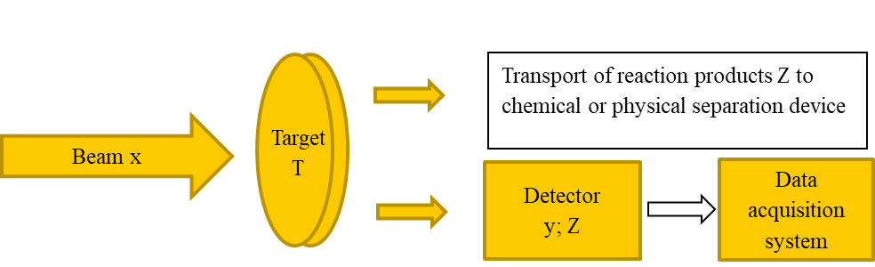
Figure 1: The components of a nuclear physics experiment including the target.
In particular, if it comes to radioactive material, only a few labs in Europe are capable to ensure this very special supply (GSI, Uni Mainz, JRC-Geel, CEA, PSI and a few others). Unfortunately, the huge efforts needed to produce and characterize high-quality samples and targets are often underestimated and experimenters do not consider an adequate budget into their proposals for funding. The result is an increasing lack of qualified personnel in the European target labs, just recently experienced by JRC-Geel and PSI. On the contrary, the demands on the sample quality are becoming ever higher, and more and more groups are calling also for isotopically pure targets. A recent attempt towards addressing this demand is currently made by PSI with the plan for build-up a dedicated mass separator. Refer to TWG8 where a more detailed description of the sample and target topic can be found.

Detector developments
Towards to the deduction of high precision nuclear data, beside the upgrade of the existing facilities and realization of future ones, the detector developments are of equal importance and special effort has to be devoted in this field of research. Especially, when we refer to nuclear information for energy, medical or other kind of applications, the precision is a key factor. In order, to fulfill these requirements dedicated experimental setups have to be developed with advanced characteristics.
The full exploitation of the intensity characteristics of future beams can be achieved through highly segmented detection setups that provide large solid angle coverage along with advanced spatial and energy resolution. On the same direction the recording of multiple observables for each event should be considered towards to more inclusive measurements. A typical example is the study of fission reaction cross sections where numerous studies have been performed so far simply by recording counting rates. On the other hand, a more complete understanding of the fission mechanism requires the comparison of the predictions of fission models with a number of observables such as the angular distribution, the charge and mass distribution of the fission fragments or even the recording of prompt and delayed (isomeric) γ-rays. Such complete measurements are scarce and this is one of the reasons that the fission process is still considered as one of the less understood nuclear phenomena.
The quality of the recorded data can be ensured only when advanced front-end electronics are employed that allow for high sampling rates and high-resolution data. The data analysis methods towards to the deduction of solid physics results should be enforced through state-of-the-art software technologies. On this respect the neural network algorithms showed already extensive abilities in pulse shape analysis techniques and in data classification tasks. Still, on the same direction, synergies with High Energy Physics experiments will be beneficial for both communities given that such an interaction could result in substantial know-how transfer on both directions.
[Nikolas Patronis] (½ page)

Data Evaluation

General purpose and specific nuclear data libraries
· The importance of data evaluation, the creation of integrated libraries and the future actions to be taken
· Evaluation & validation. Link to TWG9 related to curated data, evaluation, databases….
· Role of international agencies
[Arjan] (½ page)

Standards and metrology
Nuclear data measurements are typically simpler to execute when performed relative to reference standards. In most neutron reaction cross section measurements, for example, the direct measurement of the incident neutron fluence is replaced by the measurement of a standard reaction cross section. This also facilitates the evaluation procedure, as the results of individual experiments can be easily rescaled if the standards are re-evaluated. With increasingly stringent requirements on the target accuracy of the general-purpose libraries, it is therefore crucial to continuously work on the progress of the standards, as any improvement in the standards will cause all measurements relative to that standard to be improved.
The neutron data standard evaluation project is an international collaborative endeavour currently maintained and coordinated by the Nuclear Data Section of the IAEA. The regular releases take advantage of new and improved experimental results and of the latest development in the evaluation methodology. For the release of 2017, for example, the aspect of the ‘unrecognized sources of uncertainties’ was investigated. This led to the implementation of new qualitative and quantitative procedures to assess potentially unknown systematic uncertainties associated with the experimental data.
In the last years, the advances in nuclear technologies, medical application, air and space travel, brought up the need of high-energy neutron standards, ranging beyond the 20-MeV limit usually considered for fission applications. Great effort is being invested in extending the range of validity of certain standards; at present, two standard cross sections (235U(n,f) and 238U(n,f)) have been extended up to 200 MeV, with the objective of ideally reaching 1 GeV. The main limitation is represented by the experimental database, as measurements extending above 100 MeV are rare. For this reason, there is an increasing interest in measurement of (n,f) and (p,f) reactions at high energy up to 1 GeV, in which the main challenge is to produce absolute results with accuracy suitable for a standard.
[PTB] (½ page)

Perspectives and needs
· Attracting young people to the field: critical for the evaluation but also important for experiments & target laboratories. Very much linked to education and training, but not only.
· Better coordination between the experimental part, evaluators and end-users.
· Better coordination between the different fields.
· Strategic review.
The maintenance of competences in the nuclear data sector requires the availability of neutron beam facilities in Europe to allow early stage researchers to gain a fundamental understanding of the interaction probabilities of neutrons with nuclei.
For nuclear applications that will have societal relevance for the foreseeable future it is indispensable to continue to work on improved nuclear data. The next generation of applied nuclear physicists needs to have research infrastructures for the development of nuclear power as future.
energy source as well as for nuclear waste management and determination of the final repository safety, radiation protection and in cross-cutting activities like medical radiation therapy
· For integral validation experiments, Benchmark and Reference Neutron and Gamma-Ray fields experimental facilities in Europe are becoming very seldom. The few of them still operating should be maintained through a European support programme [We can cite some of these facilities in the 6.2 …]

[Arnd, Arjan] (½ page)

Nuclear science for a sustainable society

Towards the planet

Towards society

Towards the world, beyond Europe

Extra frames

Dosimetry
Dosimetry
Additional note on dosimetry as a whole before going to details for therapy?
Radiotherapy requires accurate dosimetry to ensure correct prescribed dose delivery and treatment protocols based on consistent and harmonized dosimetric procedures. For EBRT, reference dosimetry is based on absorbed dose to water from a photon field, considering ionization chamber (IC) and beam quality correction factors. Major community efforts have been devoted to theoretical frameworks, experimental developments and practical guidelines for IC dosimetry and calorimetry. The present code of practice (IAEA TRS-398) is under review to include more precise correction factors and current technology, e.g., PBS. Moreover, graphite calorimetry has been proposed as a primary standard for protons, considering its increased sensitivity and thermal diffusivity. However, the field still faces a number of challenges, such as the establishment of machine-specific reference fields for the transfer of the dosimetry standards, calibration transfer frameworks and the accurate characterization of radiation quality.
For TRNT, the accuracy and individualization of dose prescription is much less well stablished than for EBRT. Treatments are conventionally prescribed based on a standard activity that is safe for a population and disregard individual biokinetics or inter-patient differences. Such strategies result in treatment dose variations, with toxicity and/or under-dosage. The reluctance to perform individual patient dose measurements comes from a lack of standard methods for calibrating or implementing TRNT dosimetry in the clinic. Thus, there is an urgent need to provide the scientific and clinical community with a robust and accurate way to perform radiopharmaceutical dosimetry in a therapeutic context. Moreover, biophysical models to predict clinical endpoints of tissue toxicity based on absorbed dose and radiobiological considerations could support the implementation of individual treatment evaluation and planning in radiopharmaceutical therapy.
Needs of nuclear data?


Nuclear clock
The nuclear clock: a new tool in the nuclear arsenal
The atomic clock is a prominent example of quantum technology that is now sometimes referred to as a “first generation”. Its development has advanced the accuracy of time and frequency measurements since the 1950s by about ten orders of magnitude into the 10⁻¹⁸ range, much further than for any other physical quantity. Much of the progress with atomic clocks over the past 30 years has been achieved from the application of the methods of laser cooling and trapping of atoms and ions. First proposed in 2003, the idea of a nuclear clock is now discussed intensely. The conceptual shift from an atomic to a nuclear clock is straightforward: instead of a transition in the electron shell a radiative transition inside the nucleus will be used as the frequency reference and a laser oscillator will be stabilized to the resonance [Beeks2021]. The small size of the nucleus and tight binding of its constituents makes resonant frequencies associated with internal excitations highly insensitive to external fields, providing a strong suppression of some systematic frequency shifts that are of concern in atomic clocks. Two additional aspects contribute to the interest in a nuclear clock: First, Mössbauer gamma spectroscopy has shown that extremely high resolution may be obtained for nuclear resonances in solids. This would open an opportunity to interrogate possibly a much higher number like 10¹⁴ nuclei instead of the typically 10⁴ laser-cooled atoms in an optical clock, potentially providing a much stronger signal. Second, in contrast to the transition frequency of a valence electron, the nuclear resonance frequency is not purely determined by electromagnetic interactions but also by the strong interaction. The comparison of atomic and nuclear clocks could therefore make unique contributions to tests of fundamental physics and searches for “new physics” beyond the Standard Model based on precision clock comparisons [Peik2021].
So far only one nucleus has been identified for developing a nuclear clock in the optical frequency range: ²²⁹Th. This nucleus is unique with an isomer energy of about 8.3 eV, in the range of outer-shell electronic transitions. In addition to its relevance for a possible nuclear clock, this opens a field of low-energy nuclear physics for experimental studies, where nuclear and electronic excitations can be coupled because they appear in the same energy range. Recent experiments have provided essential information on the nuclear properties of ²²⁹Th [Beeks2021], such as the nuclear moments, decay modes of the isomer and a more precise value of the isomer excitation energy [Kraemer2023], which is required to achieve laser excitation. ²²⁹Th is studied as trapped atomic ions in vacuum or as a dopant in transparent crystals such as calcium fluoride. The isomer has been produced in the alpha decay of ²³³U and the beta decay of ²²⁹Ac. To drive the nuclear excitation resonantly with a narrow-band tunable laser remains an unresolved experimental challenge, caused by the tremendous gap of about 16 orders of magnitude between the present uncertainty in the nuclear transition frequency (of about 10 THz) and the natural linewidth (in the mHz range). A few laboratories have developed dedicated tunable laser systems in the vacuum ultraviolet at about 150 nm wavelength in order to search for the ²²⁹Th resonance. A success of these efforts will open a new field of experimental work with novel opportunities in coherent state preparation and precision frequency measurements in a nucleus.

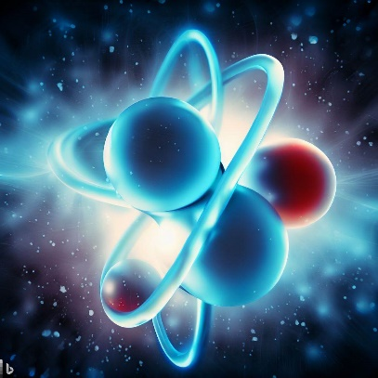
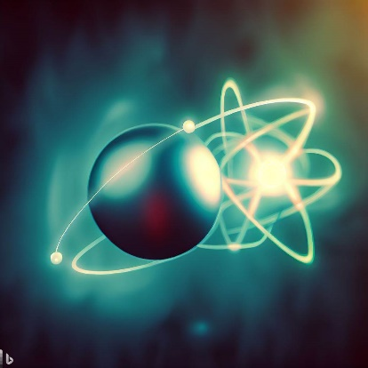
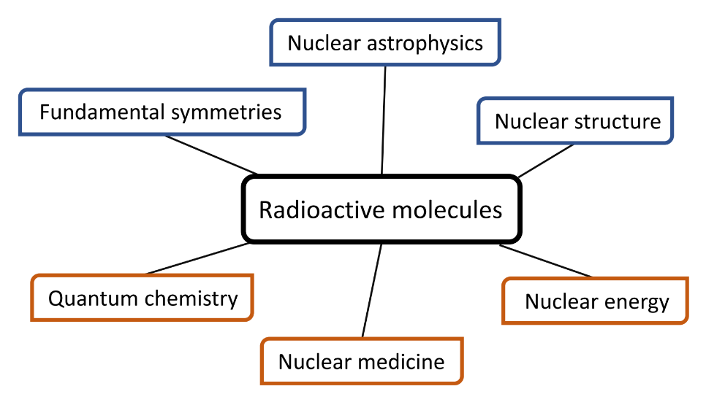
Radioactive molecules
Radioactive molecules: powerful tool and unique laboratory
The production and study of radioactive molecules is quickly acquiring momentum at radioactive ion beam facilities across Europe and beyond. The motivation for studying the structure and dynamics of molecules containing short-lived radioactive nuclei is multi-faceted and covers areas of both fundamental and applied science (Fig. 1), in regions of the nuclear chart where molecular studies have so far been too challenging.
For heavy species, gas-phase spectroscopy provides powerful benchmarks of the predictions of ab initio quantum chemistry in regions where relativistic effects are crucial, the chemistry of 5f electrons is not fully understood, and experimental data is scarce. Meanwhile, producing isotopically pure compounds of the early actinides is important for understanding the isolated molecular dynamics of relevance to nuclear engineering and radioactive waste management. Simultaneously, the optimization of the ISOL production of molecular beams that are purer and more intense than the constituent atomic beams is also of direct importance for the future of ISOL as a production plan for medical radioisotopes. Finally, some of those radioactive molecules may prove ideal laboratories for searches of physics beyond the Standard Model.

